Week 2 Unit 3

Automatic conversion with data Types

Please perform the exercises below in your app project as shown in the video.

Table of Contents

1 Usage of Data Types for Formatting 2

2 Usage of Types for Form Validation 3

## Preview

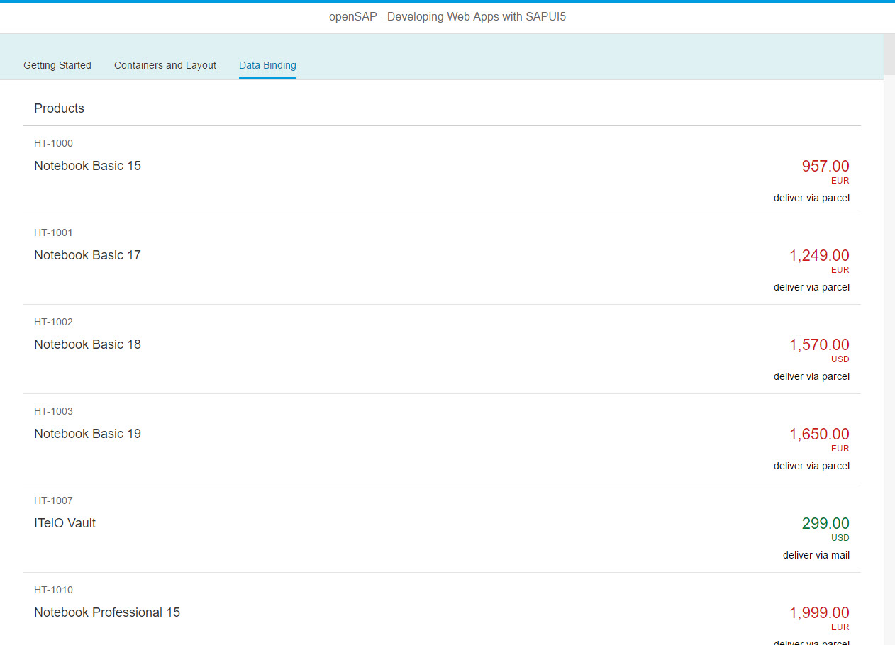

Figure 1 - Preview of the app after doing this unit’s exercises

# Usage of Data Types for Formatting

In this step, we use a data type to apply standard formatting across different currencies.

### Preview

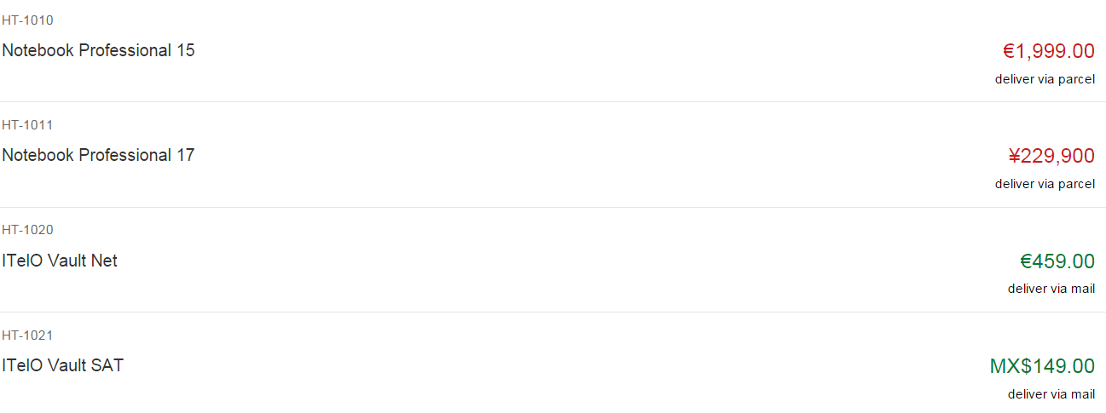

Figure 2 - Formatted currencies

### webapp/view/App.view.xml

<mvc:View …>

…

<ObjectListItem

title="{Name}"

**number="{**

**parts: [**

**{path: 'Price'},**

**{path: 'CurrencyCode'}**

**],**

**type: 'sap.ui.model.type.Currency',**

**formatOptions: {**

**showMeasure: false**

**}**

**}"**

numberUnit="{CurrencyCode}"

…>

…

</mvc:View>

In this step, we format the price displayed in the ObjectListItem control depending on the currency by applying the Currency data type on the number attribute. This is achieved by setting the type attribute of the binding syntax to sap.ui.model.type.Currency.

Additionally, we set the formatting option showMeasure to false. This hides the currency code as it is already displayed in the numberUnit attribute.

As you can see above, we use a special binding syntax for the number property of the ObjectListItem. This binding syntax makes use of so-called "Calculated Fields", which allows to pass multiple properties from different models to a formatter function or data type. The properties bound from different models are called “parts”.

We could access these two values in a custom formatter function to specify how they should be processed together. In our case, the currency type handles the formatting of the price. Please see the related documentation below for more details.

# Usage of Types for Form Validation

In this step, we add a data type to the input control from one of the previous sessions and enable automatic form validation. To keep the exercise simple and avoid adding more controls, we use the input field for the name used in the “Hello” message, although it obviously was not originally meant to require a number, but a string.

### Preview

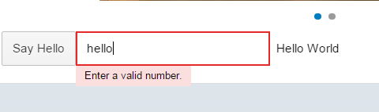

Figure 3 - Form validation based on types

### webapp/view/App.view.xml

<mvc:View …>

…

<IconTabFilter id="start" …>

…

<Input

value="**{**

**path: 'helloPanel>/recipient/amount',**

**type: 'sap.ui.model.type.Float',**

**formatOptions: {minFractionDigits: 2},**

**constraints: {maximum : 3000}**

**}**"

description="Hello {helloPanel>/recipient/name}"

**valueLiveUpdate="false"**

width="60%"/>

</IconTabFilter>

…

We will change the binding information to be able to add the type and additional format options and constraints to it. The way to add it is the same as in the list Item. We use the type sap.ui.model.Type.Float to display the entered number in a specific format. Additionally we add a constraint that has to be fulfilled and set the property valueLiveUpdate to false so that the model is not updated on every keystroke.

### webapp/manifest,json

{

…

"sap.ui5": {

"_version": "1.2.0",

"rootView": {

"viewName": "opensap.myapp.view.App",

"type": "XML",

"id": "app"

},

**"handleValidation": true,**

"autoPrefixId": true,

…

}

}

We now see automatic type conversion in the input field but not yet input validation in place. In order to achieve this, we will set automatic validation handling to true in the manifest.json file and the SAPUI5 core will handle input validation based on format options and constraints on all input controls automatically.

Now run your app again and check if the type on the input field is working by entering a number higher than 3000 or a string. You should see a red border around the input field and if you focus it you will see a validation error message.

### Related Information

[Calculated Fields for Data Binding](https://sapui5.hana.ondemand.com/docs/guide/a2fe8e763014477e87990ff50657a0d0.html)

[Custom Formatter Functions](https://sapui5.hana.ondemand.com/docs/guide/07e4b920f5734fd78fdaa236f26236d8.html)

[API Reference: sap.ui.model.type](https://sapui5.hana.ondemand.com/docs/api/symbols/sap.ui.model.type.html)

[API Reference: sap.ui.model.type.Currency](https://sapui5.hana.ondemand.com/docs/api/symbols/sap.ui.model.type.Currency.html)

[API Overview and Samples: sap.ui.model.type.Currency](https://sapui5.hana.ondemand.com/explored.html#/entity/sap.ui.model.type.Currency/samples)

[API Overview and Samples: sap.ui.model.type.Float](https://sapui5.hana.ondemand.com/explored.html#/entity/sap.ui.model.type.Float/samples)

**Coding Samples**

Any software coding or code lines/strings (“Code”) provided in this documentation are only examples and are not intended for use in a productive system environment. The Code is only intended to better explain and visualize the syntax and phrasing rules for certain SAP coding. SAP does not warrant the correctness or completeness of the Code provided herein and SAP shall not be liable for errors or damages cause by use of the Code, except where such damages were caused by SAP with intent or with gross negligence.